如何初始化我的服务器：

安装jdk8

# 更新 yum 缓存
sudo yum update

# 安装 OpenJDK 8
sudo yum install -y java-1.8.0-openjdk java-1.8.0-openjdk-devel

# 验证安装
java -version
javac -version

安装mysql8
# 清理 yum 缓存
sudo yum clean all
sudo rm -rf /var/cache/yum

# 删除旧的 MySQL 仓库配置
sudo rm -f /etc/yum.repos.d/mysql-community*

# 重新下载并安装 MySQL 仓库
sudo yum install -y https://dev.mysql.com/get/mysql80-community-release-el7-11.noarch.rpm

# 更新 GPG 密钥
sudo rpm --import https://repo.mysql.com/RPM-GPG-KEY-mysql-2023

# 安装 MySQL
sudo yum install -y mysql-community-server

修改mysql密码
# 启动 MySQL 服务
sudo systemctl start mysqld

# 设置开机自启
sudo systemctl enable mysqld

# 检查服务状态
sudo systemctl status mysqld

# 查看临时密码
sudo grep 'temporary password' /var/log/mysqld.log

# 使用临时密码登录
mysql -u root -p

-- 修改 root 密码（将 '你的新密码' 替换为你想设置的密码）
ALTER USER 'root'@'localhost' IDENTIFIED BY '你的新密码';
#当前新密码要求严格，设置为 Dingmin@111

-- 刷新权限
FLUSH PRIVILEGES;

-- 退出
EXIT;

安装redis
# 更新系统
sudo yum update -y

# 安装 EPEL 仓库（如果尚未安装）
sudo yum install -y epel-release

# 安装 Redis
sudo yum install -y redis

# 启动 Redis 服务
sudo systemctl start redis
sudo systemctl enable redis

# 检查状态
sudo systemctl status redis

创建项目目录
/opt/wholewen

将jar 前台dist目录移入
注意jar中sql的端口 密码是否对应，注意上传文件的路径是否正常

如果navicat无法连接数据库，注意3点：
- mysql是否允许远程连接（该点待定）
# 登录 MySQL
mysql -u root -p

# 查看绑定地址
SHOW VARIABLES LIKE 'bind_address';
如果显示 127.0.0.1 或 localhost，说明只允许本地连接。

# 编辑 MySQL 配置文件（直接编辑就行了）
sudo nano /etc/my.cnf
找到 [mysqld] 部分，修改或添加：
bind-address = 0.0.0.0

完整内容如下：
# For advice on how to change settings please see
# http://dev.mysql.com/doc/refman/8.0/en/server-configuration-defaults.html

[mysqld]
#
# Remove leading # and set to the amount of RAM for the most important data
# cache in MySQL. Start at 70% of total RAM for dedicated server, else 10%.
# innodb_buffer_pool_size = 128M
#
# Remove the leading "# " to disable binary logging
# Binary logging captures changes between backups and is enabled by
# default. It's default setting is log_bin=binlog
# disable_log_bin
#
# Remove leading # to set options mainly useful for reporting servers.
# The server defaults are faster for transactions and fast SELECTs.
# Adjust sizes as needed, experiment to find the optimal values.
# join_buffer_size = 128M
# sort_buffer_size = 2M
# read_rnd_buffer_size = 2M
#
# Remove leading # to revert to previous value for default_authentication_plugin,
# this will increase compatibility with older clients. For background, see:
# https://dev.mysql.com/doc/refman/8.0/en/server-system-variables.html#sysvar_default_authentication_plugin
# default-authentication-plugin=mysql_native_password

datadir=/var/lib/mysql
socket=/var/lib/mysql/mysql.sock

log-error=/var/log/mysqld.log
pid-file=/var/run/mysqld/mysqld.pid

bind-address = 0.0.0.0

重启 MySQL：
sudo systemctl restart mysqld

- MySQL 默认 root 用户可能只允许本地访问：（该点待定）
-- 登录 MySQL
mysql -u root -p

-- 创建远程访问用户（或者修改 root 权限）
CREATE USER 'root'@'%' IDENTIFIED BY '你的密码';
GRANT ALL PRIVILEGES ON *.* TO 'root'@'%' WITH GRANT OPTION;
FLUSH PRIVILEGES;

-- 或者修改现有 root 用户的访问权限
UPDATE mysql.user SET host='%' WHERE user='root';
FLUSH PRIVILEGES;

-- 查看用户权限
SELECT user, host FROM mysql.user;

- 观察服务器是否开启了端口
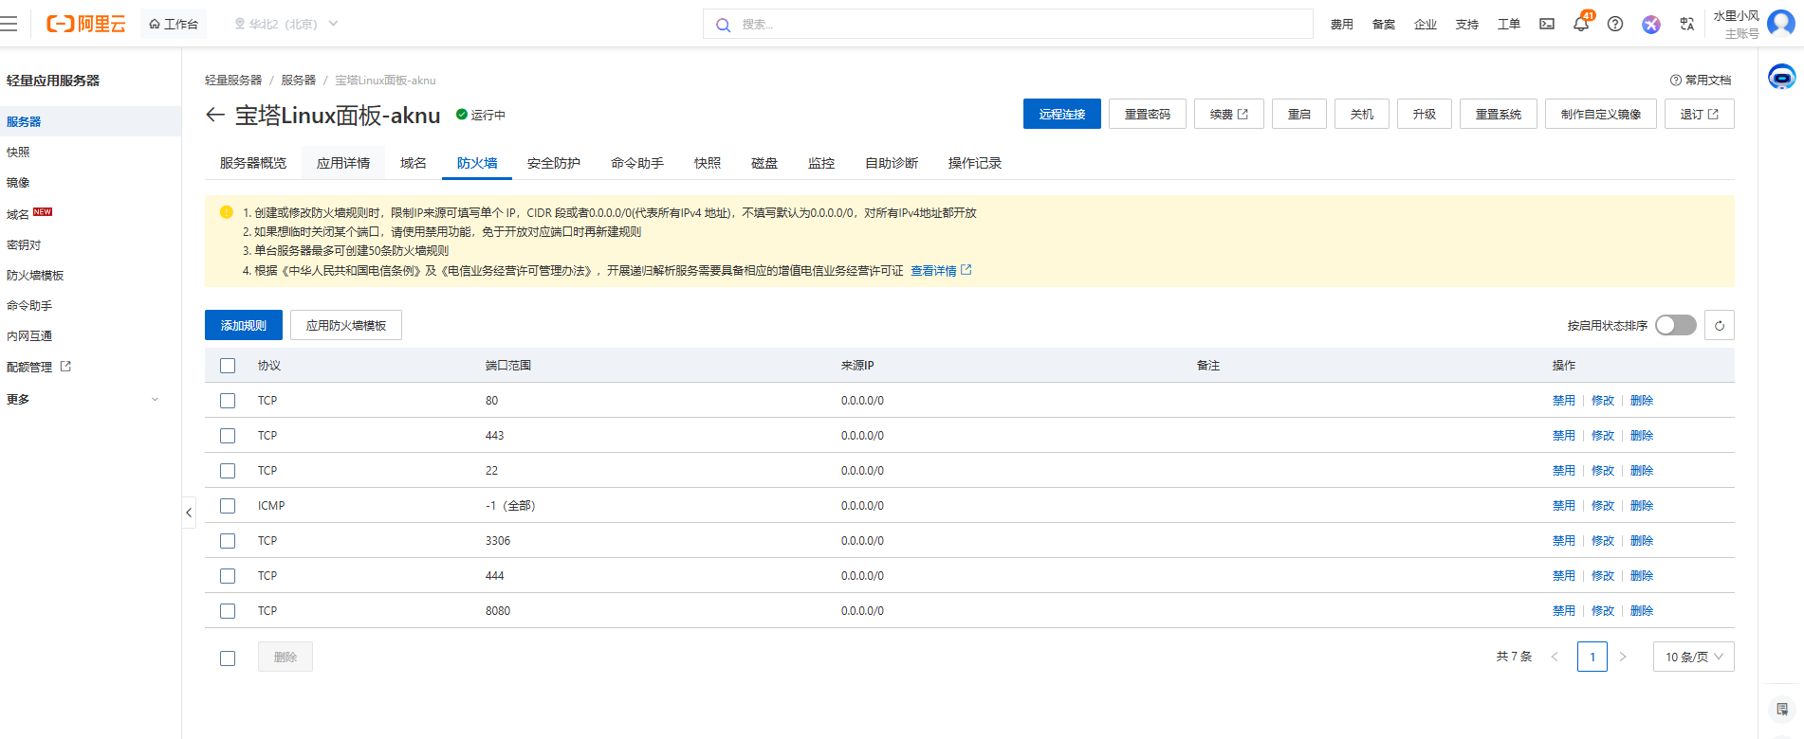

linux关闭端口
# 方法一：使用 lsof 命令
sudo lsof -i :444

# 方法二：使用 netstat 命令
sudo netstat -tlnp | grep 444

# 方法三：使用 ss 命令
sudo ss -tlnp | grep 444

# 方法四：使用 fuser 命令
sudo fuser 444/tcp

# 根据 PID 杀死进程（12345 是示例 PID）
sudo kill 12345

# 如果普通 kill 不行，使用强制杀死
sudo kill -9 12345

安装nginx
Aliyun可能禁止安装nginx，改用 Tengine（阿里官方推荐，完全兼容 Nginx）
安装 Tengine
sudo dnf install tengine -y

启动并启用服务
sudo systemctl start tengine
sudo systemctl enable tengine
sudo systemctl status tengine # 查看是否运行

开放防火墙
sudo firewall-cmd --permanent --add-service=http
sudo firewall-cmd --reload

此时浏览器访问ip，应该会看到 Tengine 的欢迎页面（和 Nginx 几乎一样）

修改Tengine 的配置文件 /etc/tengine/nginx.conf
修改说明：
client_max_body_size 50M; 处理文件上传大小限制
root /opt/wholewen/dist; 指定前端目录
location /prod-api/ 指定生产环境路径
location /profile/ 指定上传文件后，返回文件展示的路径映射

完整内容为：
# For more information on configuration, see:
# * Official English Documentation: http://nginx.org/en/docs/
# * Official Russian Documentation: http://nginx.org/ru/docs/

user tengine;
worker_processes auto;
worker_cpu_affinity auto;
error_log /var/log/tengine/error.log;
pid /run/tengine.pid;

# TODO: No dynamic modules for now in Tengine
include /usr/share/tengine/modules/*.conf;

events {
worker_connections 1024;
}

http {
log_format main '$remote_addr - $remote_user [$time_local] "$request" '
'$status $body_bytes_sent "$http_referer" '
'"$http_user_agent" "$http_x_forwarded_for"';

lua_package_path "/usr/lib/lua/?.lua;;";

access_log /var/log/tengine/access.log main;

sendfile on;
tcp_nopush on;
tcp_nodelay on;
keepalive_timeout 65;
types_hash_max_size 2048;

include /etc/tengine/mime.types;
default_type application/octet-stream;

# Load modular configuration files from the /etc/tengine/conf.d directory.
# See http://nginx.org/en/docs/ngx_core_module.html#include
# for more information.
include /etc/tengine/conf.d/*.conf;

server {
listen 80 default_server;
listen [::]:80 default_server;
server_name _;
root /usr/share/tengine/html;

# ��������ϴ� 50MB
client_max_body_size 50M;

# Load configuration files for the default server block.
include /etc/tengine/default.d/*.conf;

location / {
root /opt/wholewen/dist;
try_files $uri $uri/ /index.html;
index index.html;
}

error_page 404 /404.html;
location = /40x.html {
}

error_page 500 502 503 504 /50x.html;
location = /50x.html {
}

location /prod-api/ {
proxy_pass http://localhost:8080/;
proxy_set_header Host $host;
proxy_set_header X-Real-IP $remote_addr;
proxy_set_header X-Forwarded-For $proxy_add_x_forwarded_for;
proxy_set_header X-Forwarded-Proto $scheme;
}

location /profile/ {
alias /home/ruoyi/uploadPath/;
expires 30d;
add_header Cache-Control "public, immutable";
}

}

# Settings for a TLS enabled server.
#
# server {
# listen 443 ssl http2 default_server;
# listen [::]:443 ssl http2 default_server;
# server_name _;
# root /usr/share/tengine/html;
#
# # Async SSL acceleration for both CPU ISA and PCIe QAT
# listen 443 ssl reuseport backlog=131072 so_keepalive=off rcvbuf=65536 sndbuf=65536;
# server_name localhost;
# keepalive_timeout 0s;
# access_log off;
# ssl_async on; #off # not ssl_asynch
# ssl_verify_client off;
# ssl_session_tickets off;
# ssl_session_timeout 300s;
# ssl_session_cache off;
# ssl_protocols TLSv1.2;
# ssl_ciphers AES256-SHA;
# ssl_ciphers AES256-GCM-SHA384;
# ssl_ciphers ECDHE-RSA-AES256-GCM-SHA384;
# ssl_ecdh_curve X25519;
# ssl_ecdh_curve P-256;
# ssl_prefer_server_ciphers on;
# ssl_certificate /etc/tengine/cert/server.crt;
# ssl_certificate_key /etc/tengine/cert/server.key;
# ssl_certificate /etc/tengine/cert/ecdsa.crt;
# ssl_certificate_key /etc/tengine/cert/ecdsa.key;
#
# FIXME: the cert and key are not ready yet in Tengine.
# ssl_certificate "/etc/pki/tengine/server.crt";
# ssl_certificate_key "/etc/pki/tengine/private/server.key";
# ssl_session_cache shared:SSL:1m;
# ssl_session_timeout 10m;
# ssl_ciphers PROFILE=SYSTEM;
# ssl_prefer_server_ciphers on;
#
# # Load configuration files for the default server block.
# include /etc/tengine/default.d/*.conf;
#
# location / {
# }
#
# error_page 404 /404.html;
# location = /40x.html {
# }
#
# error_page 500 502 503 504 /50x.html;
# location = /50x.html {
# }
# }

}

修改文件后可以测试是否正常
sudo /usr/sbin/tengine -t

然后重载服务
sudo systemctl reload tengine

打包运行注意事项
如果tengine已经部署好，访问首页报错，大概率是后台项目关闭了。可以尝试在后台执行jar:
nohup java -jar your-app.jar > app.log 2>&1 &

参数说明：
nohup：忽略挂断信号（SIGHUP），终端关闭后进程不退出
> app.log：将标准输出重定向到 app.log 文件
2>&1：将错误输出也合并到 app.log
&：放入后台运行
如果启动失败，可能是因为用户权限不足，可以直接切root:
su -
然后输入密码即可

当前页面可以访问后，请求的接口路径总是异常，在浏览器上显示的是访问localhost，导致请求失败，即使不断修改生产环境的配置文件也不生效，做了如下两处修改可以了，但是不确定是否是正确的原因：
- package.json中
"build:prod": "vue-cli-service build"
打包命令使用npm run build:prod
- .env.production中
VUE_APP_BASE_API = /prod-api
/prod-api两边没有引号，重新打包就生效了，不知道什么问题
同时按照大模型的说法，Vue CLI 只会把以 VUE_APP_ 开头的变量注入到客户端代码中，所以我打印process.env.ENV的值发现也是undefined，搞不懂

后续如果上传文件有大小限制，以及回显的时候请求的路径如果和目录不一致，参看tengine的配置文件即可

