- 华为云域名服务
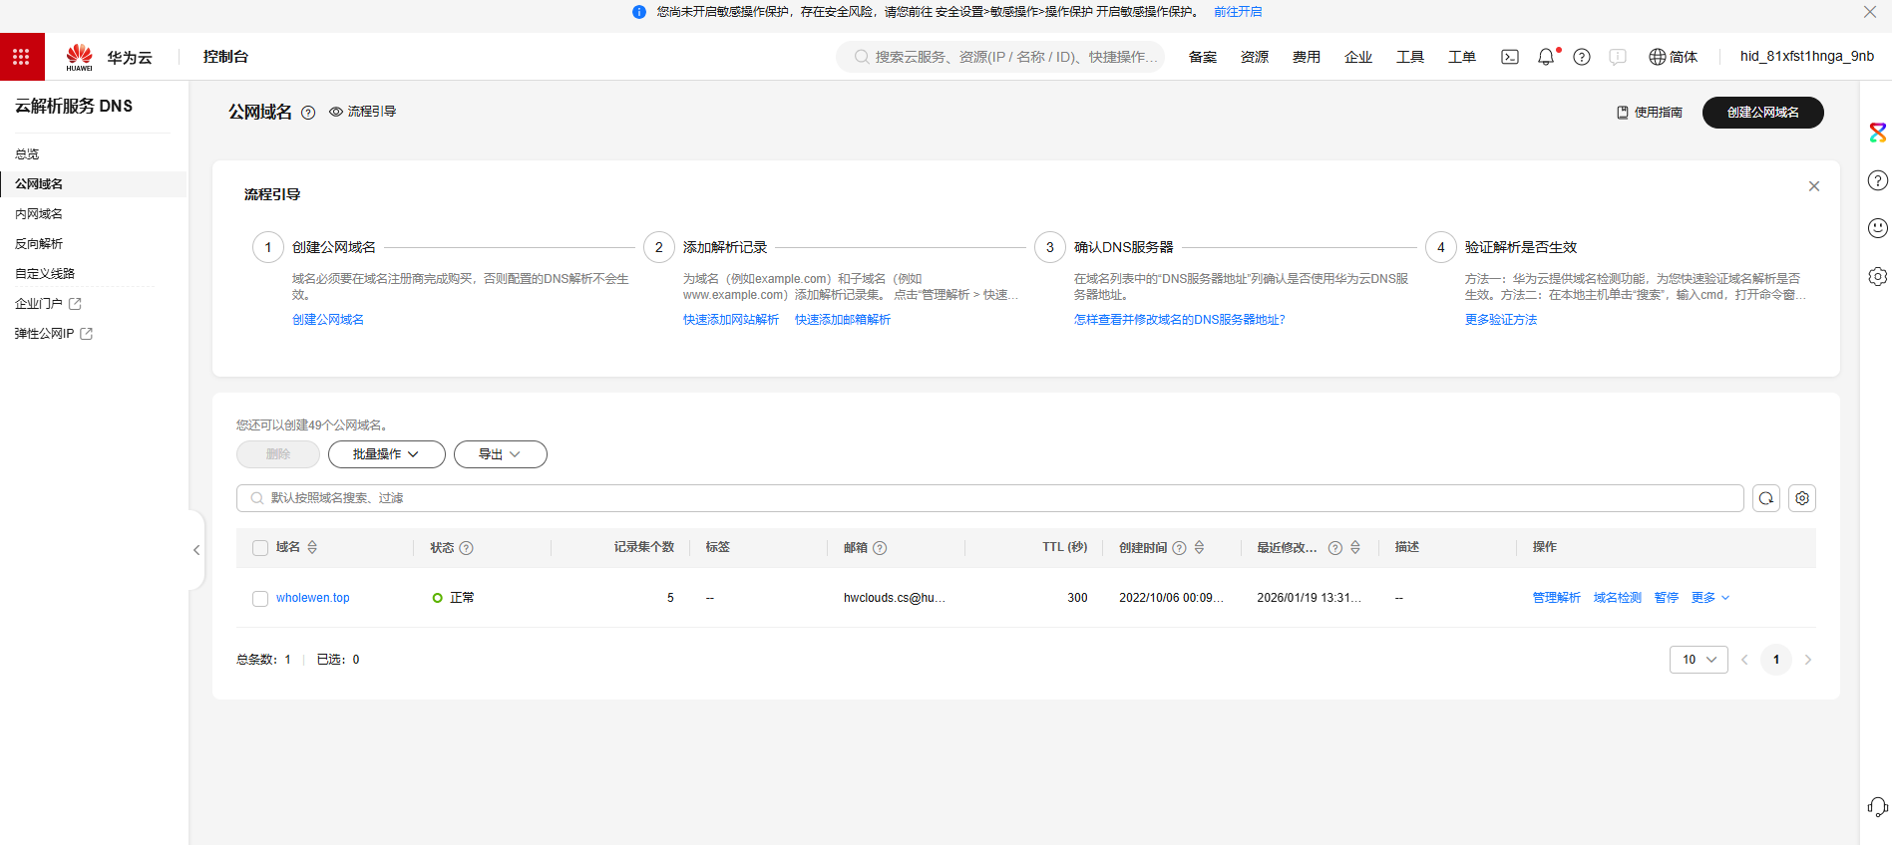
https://console.huaweicloud.com/dns/?agencyId=0d532723cf0091f21fe2c01968530113&region=cn-east-3&locale=zh-cn#/dns/publiczones

- 阿里云SSL证书管理
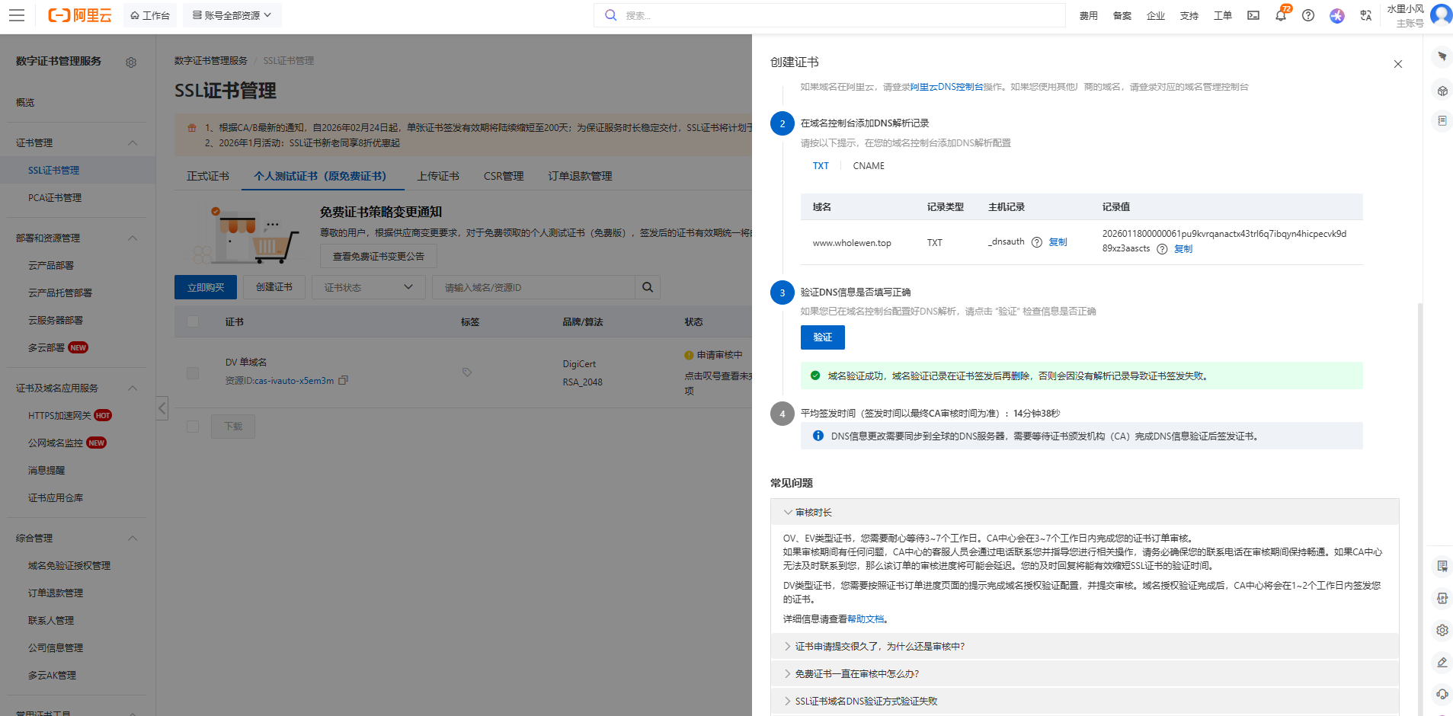
https://yundun.console.aliyun.com/?spm=5176.7968328.J_8413632810.3.7cae70d5IjTTHI&p=cas#/certExtend/free/cn-hangzhou?adSearchParams=%7B%22Keyword%22%3A%22%22%2C%22CurrentPage%22%3A1%7D

- 华为云解析
具体操作参大模型
